Survey for small and medium-sized companies and intermediary organizations: research report
EAPPREN
Capacity Building for Intermediary Organisations through e-learning
EAPPREN - 572727-EPP-1-2016-1-EL-EPPKA3-SUP-APPREN

WP: 2
Deliverable 2.3 Training Needs Analysis
Prepared by: CCIS

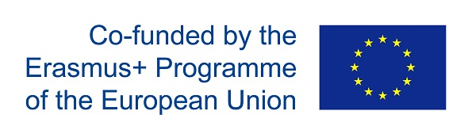
Table of Contents
Introduction 3
2. Methodology 4
2.1 Participants 4
2.2 Target numbers 4
2.3 Design 4
2.4 Terminology 5
3. Results 6
3.1 Small and medium-sized enterprises (SMEs) 6
3.1.1 SMEs which are not involved in WBL 8
Match-making between students and companies 10
Mentoring and internal organization of work 10
Support network and collaboration 11
Vocational education as career option 11
3.1.1 SMEs which are involved in WBL 13
Match-making between students and companies 15
Mentoring and internal organization of work 15
Support network and collaboration 15
Vocational education as career option 16
3.2 Intermediary organizations (IMOs) 18
Source of financing of IMOs 18
Cooperation 19
Improvement of service offer 20
Improvement of competences 21
Preferred options for training 23
4. Conclusions 23
5. Annexes 23
5.1 Infographics TBA 23
5.2 Data tables TBA 23

Introduction

In many countries of Southern and Eastern Europe, current legislative reform is moving the work-based learning system from a 100% school-based system towards a company based system. However, neither the intermediary organisations nor the companies are prepared to cope with this change.
Young people all over Europe, but specifically in the Southern and Eastern part of the continent have been affected particularly hard by the economic crisis. It has been proved that work-based learning in the form of an apprenticeship is of significant importance in helping young people to make a smoother transition from education to work (European Commission, Guidance Framework, Support for companies, in particular SMEs, offering apprenticeships: Seven guiding principles).
In a 100% school-based system, schools carry all the responsibility, with hardly any obligations for the chambers and none for the companies. Now new laws on apprenticeship are being adopted in many of the partner countries, some of them already started with the implementation and some of them will start soon.
With new legislation come new responsibilities and roles of chambers and companies are being redefined. Different needs emerge with these new roles.
First step in coping with these changes is to identify the ways for raising awareness on the importance of work-based learning/apprenticeship and their promotion, as well as improving the image of vocational education and training in general.
Second step is to identify specific knowledge and skills that both companies and intermediary organizations need in implementing WBL/apprenticeship.
Aim of this report is to summarize the results of the desk and field research organized in all partner countries. Field research was conducted in a form of two questionnaires, one with intermediary organizations (IMOs) as target group, other one with small and medium-sized enterprises (SMEs).
The main aims of the questionnaires were:
- to identify the current situation in relation with the organization of apprenticeships and the role of intermediary organizations;
- to identify the training needs of staff working in intermediary organizations in relation with the organization of apprenticeships;
- to identify the current situation and the training needs of SMEs in relation with the organization of apprenticeships.

2. Methodology

2.1 Participants
SMEs face particular challenges in engaging in apprenticeships or other forms of WBL, given their smaller workforce, their limited resources, lack of managerial and organization capacities for management of apprenticeships and lack of familiarity with the administrative and regulatory framework. Here is a collection of the most common reasons, why SMEs do not engage in apprenticeship, which were explored in the survey (see 3.1):
- have no time for education of apprentice
- cannot offer all needed content of VET
- currently no need for new workers
- benefit of having own apprentice is too low (rather take skilled workers from labour market)
- VET process is too complex/too much administration (regulations)
- costs are too high (time)
- apprentice does not spend enough time in company
- no (appropriate) candidates
- no future need of skilled workforce
- apprentice too often leave company after VET
- missing qualified mentor for apprentices
The chambers of commerce with the previous system did not have any role in the organisation of apprenticeships and thus they lack the skills and competencies that they are necessary in order to support the companies in this regard. Also, since with the previous system there were not any obligations for the companies, they are now not ready to assume important responsibilities without the proper preparation.
Intermediary organisations, such as chambers, sectoral organisations and other organizations, can facilitate WBL and the involvement of SMEs.

2.2 Target numbers
The target numbers identified prior to the survey implementation were as follows:
- 200 SMEs – each partner country collects 25 surveys and 25 surveys from EfVET, which covers other European countries.
- 100 IMOs – Greece, Bulgaria, Poland and EfVET collect 15 surveys, Cyprus, Spain, Slovenia and Latvia collect 10 surveys.
Total surveyed number of SMEs was 438, among them 190 units were valid and analysed.
Total surveyed number of IMOs was 179, among them 95 units were valid and analysed.

2.3 Design
Online survey in English language was designed, with partners having also the flexibility to use other means of collecting the data if they considered them more convenient. However, only data inserted in the online survey was processed for the national reports and final comparative report.
Both questionnaires included closed questions, partly with the possibility of multiple answers and open questions.
The answers were processed anonymously, however the possibility to stay in touch and receive further information on project events and outputs was offered to SMEs and intermediary organizations which participated in the survey.
After some introductory questions, SMEs surveyed divided in two groups, depending whether they are or are not involved in providing WBL.

2.4 Terminology
Work-based learning (WBL) as part of Vocational Education and Training (VET) is directly linked to the mission of VET to help learners to acquire knowledge, skills and competences essential in working life. In line with the EC The Communication on Rethinking Education, three models of WBL are identified:
Apprenticeship
Apprenticeship is based on the integration of companies as training providers with VET schools and other training institutes. The learners spend a significant time on training in companies, they may be contractually linked to the employer and/or receive a remuneration. The employer must offer apprentice training leading to a specific occupation, social partners/intermediary organisations take responsibility for the quality of the company-based training of the apprentice. Apprenticeships typically include a long-term training period and higher amount of training in the workplace in comparison to other forms of training.
On-the-job training periods in companies
On-the-job trainings cover internships, work placements or traineeships that are incorporated as compulsory or optional element of VET programmes leading to formal qualifications. They can be of varying duration, but are typically less than 50% of the training programme duration, intended to allow learners to familiarize themselves with the world of work. Sometimes, they are obligatory to successfully complete a VET programme.
WBL integrated in a school-based programme
In school-based VET programmes WBL is integrated through on-site labs, workshops, kitchens, restaurants, junior or practice firms, simulations or real business/industry project assignments. In this model, VET schools are responsible to create “real life” work environments and teachers design learning activities (in cooperation with companies).
Many countries combine the three models of WBL. In our research, we focused on the first two models of WBL: apprenticeship and on-the-job training in companies.
Therefore, definition of apprenticeship was provided at the beginning of the questionnaires: “Apprenticeship is practical learning experience in companies, which is part of the formal system of vocational education and training; it combines enterprise-based and school-based training (dual learning principles); it leads to a national qualification; it might involve a contractual relationship between employer and apprentice.”

3. Results
Data analysis was conducted mostly on the basis of descriptive statistics. The data was also partly explored in order to see if there is a connection between SMEs’ size (number of employees) and some other variables.

3.1 Small and medium-sized enterprises (SMEs)
SMEs that participated in the survey come from the following countries (project partner countries): Bulgaria, Cyprus, Greece, Latvia, Poland, Slovenia and Spain; other European countries covered by EfVET.
Figures 1a and 1b show distribution of the surveyed SMEs by number of employees and by country. 51% of SMEs surveyed have 1-10 employees, 28% have 11-50 employees and 21% have 51-250 employees.
Figure 1a. Frequency distribution of number of employees in SMEs (%)
Number of employees (n = 190)
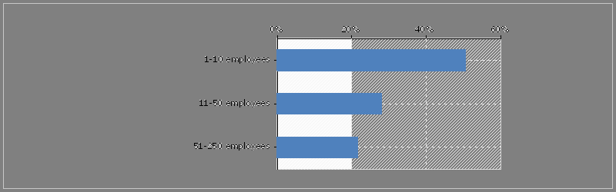
Figure 1b. Frequency distribution of number of employees in SMEs by country (%)
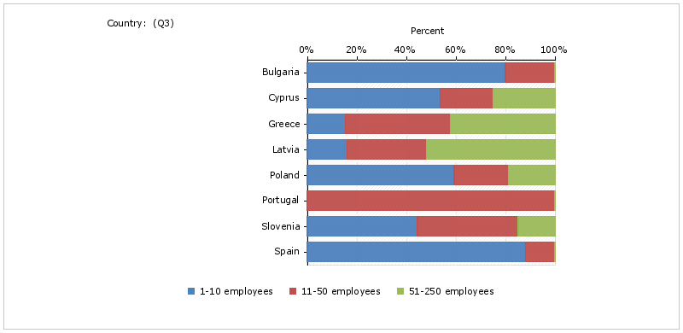

SMEs generally assessed the employability of young people after completing their vocational education and training as good, i.e. neither good or bad (2.4-2.9 average score on a scale 1-5, 1-very good, 5-very bad). Interpretation?
Figure 2. Assessment of employability of young people after completing their VET
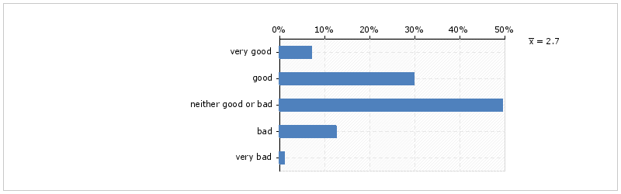
Figure 3 shows the involvement of the surveyed SMEs in providing some type of WBL to students during their VET. 40% of the surveyed SMEs are involved and 60% of them are not.
Figure 3. Involvement of SMEs in providing WBL

Further analysis (residuals) indicated that there is a connection (strength?) between company size and involvement in WBL/apprenticeship – 75% of SMEs with 1-10 employees are not involved in WBL, while 68% of SMEs with 51-250 employees are involved in WBL. Therefore, we can say that SMEs with larger number of employees are more involved in WBL/apprenticeship, primarily due to better financial/operational capacities, as we will see presented further on.
Figure 4. Frequency distribution of involvement in WBL/apprenticeship
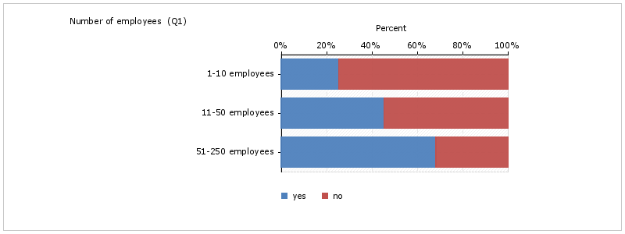

3.1.1 SMEs which are not involved in WBL
When asked about the reasons why they are not involved in providing work-based learning activities in VET, SMEs which are not involved (n=112) ranked issues that were listed as follows (multiple answers were possible):
- we are not aware that this possibility exists (34%)
- we do not have enough support from other organizations to provide WBL activities (29%)
- we do not have financial/operational capacities (23%) SMEs with 1-10 (73%) scored high here, while SMEs with 51-250 employees did not rank this as a relevant reason at all (0%);
- we do not need new staff in the next years (17%)
- we have no interest from vocational students to come to us (14%)
- we do not have qualified staff to deal with vocational students (14%)
- benefit of having a vocational student is too low (13%)
Figure 5a. Why SMEs are not involved in WBL/apprenticeship
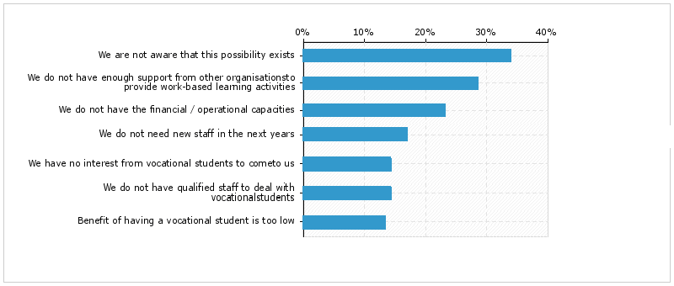
Figure 5b. Why SMEs are not involved in WBL/apprenticeship by country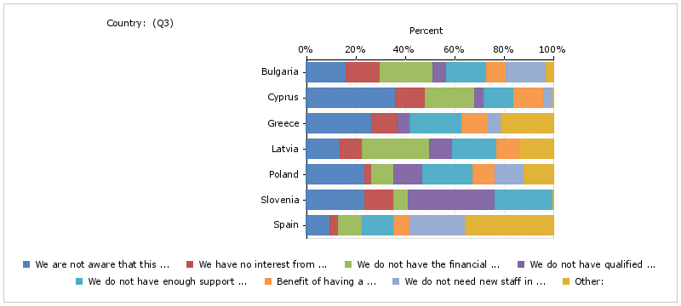
Figure 5c. Why SMEs are not involved in WBL/apprenticeship by company size
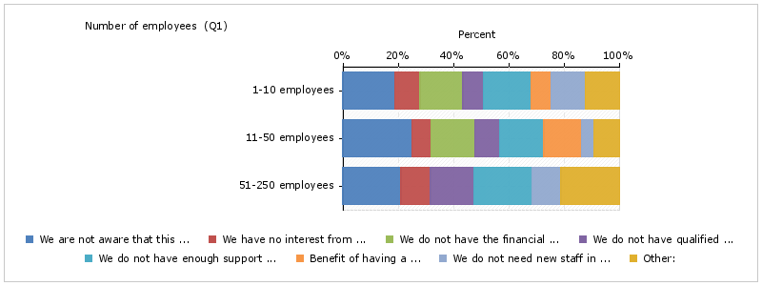

There were several elements identified in the research design as relevant for engaging in work-based learning/apprenticeship, namely:
- match-making between students and companies
- mentoring and internal organization of work
- support network and collaboration
- vocational education as career option
Respondents were asked to rank some possible difficulties in relation to each of these elements (on a scale from 1-5, 1 - not relevant at all, 5 – very relevant). Results are presented generally, with some of them depending on country and company size.

Match-making between students and companies
General results show that listed difficulties in relation to WBL regarding the match-making between students and companies are neither relevant nor irrelevant (on a scale 1-5, 5 being very relevant).

Figure 6. Reported relevance of difficulties regarding match-making between students and companies
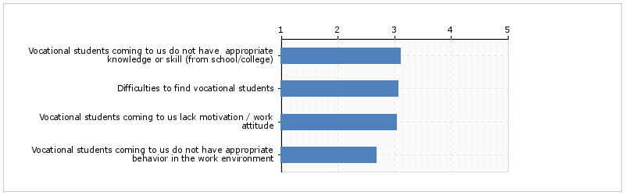
However, there are noticeable differences between surveyed countries, which lead to the general result.
Following difficulties were ranked highest, being most relevant, in Latvia – Vocational students coming to us do not have appropriate behavior in work environment and Vocational students coming to us lack motivation/work attitude (average score 4.3); Vocational students coming to us do not have appropriate knowledge or skill (from school/college) (4.1); Difficulties to find vocational students (3.6).
In Bulgaria and Slovenia, SMEs ranked following difficulty as most relevant: Difficulties to find vocational students (3.8, 3.7), while the same issue was scored as irrelevant in Spain (1.9), as well as the Vocational students coming to us do not have appropriate behavior in the work environment (1.7).
In Poland, the issue of vocational students lacking motivation/work attitude was scored as the most relevant (3.5).

Mentoring and internal organization of work
General results tend to have the average score of 3 (2.87). Further presented will be the results for those countries whose SMEs ranked the listed issues above and under the average.
SMEs in Latvia ranked following issues as most relevant:
- The activity of our company is so specialized that we cannot provide the whole range of required learning content to the vocational students (4.3)
- We lack time to deal with VET students (3.9)
- We lack knowledge/tools to better monitor and supervise apprenticeships and work-based learning in our company (3.8)
- We lack time to participate in (the obligatory) mentor training (3.7)
- We have difficulties to provide (the required) qualified mentors for VET students (3.6)
- We lack knowledge on how to better manage our vocational students and organize our work internally (3.6)
SMEs in Slovenia ranked following issues as most relevant:
- We have difficulties to provide (the required) qualified mentors for VET students (4.9)
- We lack knowledge/tools to better monitor and supervise apprenticeships and work-based learning in our company (4.4)
- We lack knowledge on how to better manage our vocational students and organize our work internally (4.4)
- We lack time to deal with the VET students (3.9)
- We lack time to participate in (the obligatory) mentor training (3.7)
SMEs in Poland ranked the following issue as most relevant:
- We lack time to deal with the VET students (3.8)
On the other hand, following issues were ranked as least relevant by the SMEs in Spain:
- We lack knowledge/tools to better monitor and supervise apprenticeships and work-based learning in our company (1.6) also low relevance in Bulgaria (2.0) and Greece (2.1)
- We lack knowledge on how to better manage our vocational students and organize our work internally (1.6) also low relevance in Bulgaria (2.0), Cyprus (2.2) and Greece (2.4)
- The activity of our company is so specialized that we cannot provide the whole range of required learning content to the vocational students (1.7)
- We have difficulties to provide (the required) qualified mentors for VET students (1.9) also low relevance in Greece (2.4)

Support network and collaboration
As most relevant for the SMEs in all participating countries, there was a need for better cooperation with vocational schools/colleges (3.8), scoring highest in Slovenia (4.7) and Poland (4.4).
Other general results centered again around score of 3, with some exceptions. SMEs from Slovenia (4.7), Greece (3.8), Latvia (3.7) and Poland (3.5) ranked need for better collaboration with chambers/sectoral organizations/other training institutions as relevant.
Slovenia (4.3) and Latvia (3.9) ranked need for better collaboration with other SMEs offering apprenticeships/work-based learning as relevant.

Vocational education as career option
With average score of 4.2, SMEs from all the countries ranked the statement that “more information for students about vocational education as career option should be provided” as relevant (Slovenia 4.7, Bulgaria 4.6, Greece and Latvia 4.3, Poland and Spain 4.1), Cyprus 3.7).
With average score of 3.9, SMEs from all the countries also ranked the statement that “the image and prestige of vocational education should be raised” as relevant (Slovenia 4.7, Greece 4.4, Latvia 4.3, Bulgaria 3.9, Poland 3.8, Cyprus 3.5; exception – Spain, 3.3).

Figure 7. Reported relevance of perceived main hindrances for not engaging in work-based learning in relation to choosing vocational education as a career option.
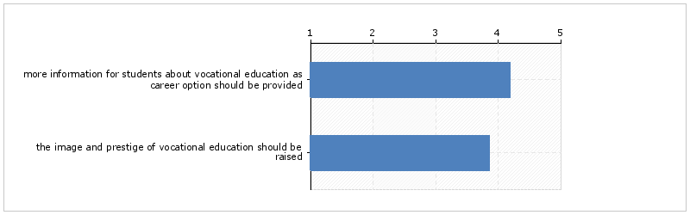
Among all the issues, raising awereness on apprenticeship and improving the image of VET in general are by far most important according to the surveyed SMEs which are not involved in WBL.

When asked to state other issues, not mentioned in the questions, SMEs provided these answers: lack of free resources to teach and support students (LV); lack of proper engagement of schools in cooperation with entrepreneurs in the field of vocational practices (PL); taking students as a major commitment, legal limitations for small businesses make it difficult to have apprentices, political issues making it difficult to participate in the apprenticeship, lack of sufficient theoretical knowledge to successfully participate in work-based part of the programme, problems with the implementation (ES).
In general, SMEs expect support from following organizations in case they would once take an apprentice: VET school (52%; BG 40%, CY 58%, EL 64%, LV 73%, SI 71%, ES 47%), chamber (39%; BG 70%, CY 42%, EL 7%, LV 64%, PL 33%, SI 86%, ES 0%), sectoral organization (26%), other training institutions (23%).
Other (13%): local labour office, technical universities, faculties of pedagogics, families.
Figure 8. Expected support from organizations in case the SME decided to partake in an apprenticeship programme
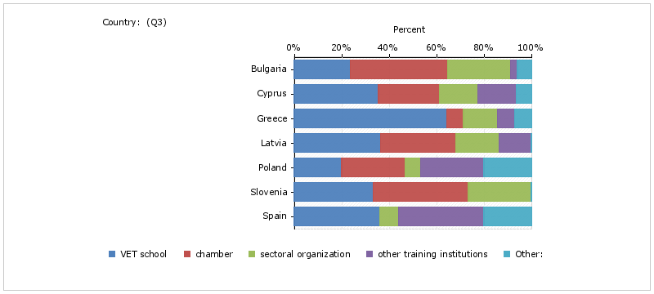

3.1.1 SMEs which are involved in WBL
In general, SMEs which are involved in providing work-based learning experiences, are mostly involved in a way that they offer places for work-based learning for vocational students in cooperation with local vocational schools or colleges (contract with vocational school) (51%).
Figure 9. Ways of involvement of SMEs
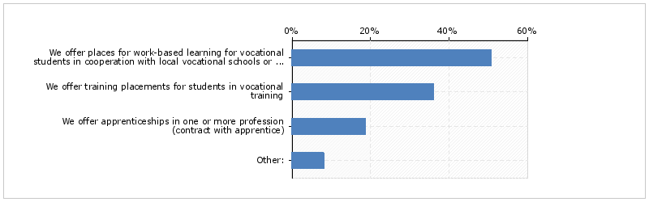

In Bulgaria, 60% of SMEs offer training placements, 20% places for WBL and 20% offer apprenticeships.
Cyprus – 50% of SMEs offer training placements, 38% offer apprenticeships.
Greece – 42% of SMEs offer training placements, 50% offer apprenticeships.
Latvia – 50% of SMEs offer training placements, 43% offer apprenticeships.
Poland – 67% of SMEs offer training placements, 44% offer places for WBL in cooperation with local VET schools.
Slovenia – 79% of SMEs offer training placements, 21% offer apprenticeships.
Spain – 33% of SMEs offer places for WBL in cooperation with local VET schools, 33% offer training placements, 17% offer apprenticeships.
In general, student usually spends 1-2 months per school year in SMEs in participant countries (43%; Bulgaria, Slovenia, Spain) or 3-6 months per school year (42%; Greece, Cyprus, Latvia, Poland).
In general, 47% of in-company trainers (mentors) receive a training to prepare themselves for this task and 53% do not, with Slovenia (74%), Poland (60%) and Greece (50%) ranking highest and Latvia (79%), Cyprus (63%) and Bulgaria (60%) lowest, i.e. mentors in SMEs there more often do not receive a training.
Figure 10. Availability of mentor training by countries
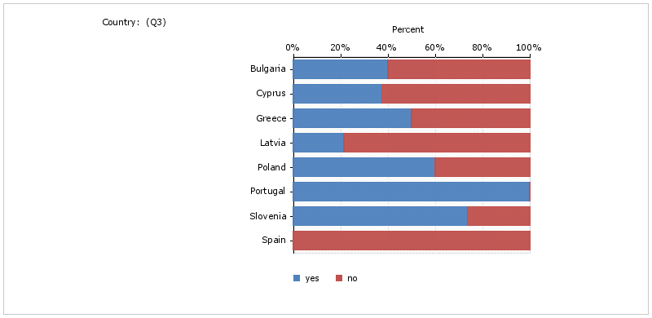
There was some additional information given by the SMEs on the in-company mentors' training:
- in Cyprus, mentors usually have training on company procedures and documentation
- in Latvia, there are trainings on mentors' role, interactions between mentor and mentee and progress measurement
- in Poland, there is a person specialized for training mentors, as well as an employee whose task is to take care of administration of the apprenticeships and other employee – mentor – who works with the apprentice
- in Portugal, training is obligatory and organised by chambers and schools
- in Slovenia, trainings are obligatory and organized by chambers in cooperation with the Ministry of education

Similar to the set of questions for SMEs which are not involved in WBL, there were several elements identified in the research design as relevant for engaging in work-based learning/apprenticeship, namely:
- match-making between students and companies
- mentoring and internal organization of work
- support network and collaboration
- vocational education as career option
Respondents were asked to rank difficulties they are experiencing in relation to each of these elements (on a scale from 1-5, 1 - not relevant at all, 5 – very relevant). Results are presented generally, with some of them depending on country and company size.

Match-making between students and companies
In general, on average SMEs from all the countries (who are already involved in WBL/apprenticeships) ranked following difficulties as relevant in regards to match-making between students and companies:
- Vocational students coming to us lack motivation/work attitude – 3.9 (BG 4.0, EL 4.0, LV 3.6, PL 4.2, SI 4.4, ES 3.3, CY 2.7)
- Vocational students coming to us do not have appropriate knowledge or skills (from school/college) – 3.7 (EL 4.1, LV 3.6, PL 3.9, SI 3.9, CY 3.3, BG 3.2, ES 2.7)
- Vocational students coming to us do not have appropriate behaviour in the work environment – 3.6 (EL 4.0, PL 3.9, SI 4.3, ES 3.0, LV 3.0, BG 2.8, CY 2.7)
- Difficulties to find vocational students – 3.6 (SI 4.3, EL 3.8, PL 3.6, CY 3.4, LV 3.3, BG 2.8, ES 2.0)

Mentoring and internal organization of work
In general, on average SMEs from all the participant countries ranked following issues as most relevant in regards to mentoring and internal organization of work:
- We lack time to deal with VET students – 3.7 (SI 4.4, LV 3.9, EL and PL 3.5, CY 3.3, ES 2.7, BG 2.4)
- We lack time to participate in (the obligatory) mentor training – 3.6 (SI and LV 3.8, CY 3.7, EL 3.6, PL 3.4, BG 3.2, ES 2.7)

Support network and collaboration

In general, SMEs from all the countries ranked following issues in regards to support network and collaboration as most relevant:
- We need better cooperation with vocational schools/colleges – 4.0 (exception of ES with score 3.2)
- We need better collaboration with chambers/sectoral organizations/other training institutions – 4.0 (exception of PL with score 3.4)
- We need better collaboration with other SMEs offering apprenticeship/work-based learning - 3.5 (BG 4.6, SI 4.1, ES 3.5, EL 3.3, LV 3.2, CY 3.0, PL 2.6)

Vocational education as career option

Similar to SMEs which are not involved in apprenticeship/WBL, with even higher scores, SMEs from all countries ranked following issues as very relevant in regards to vocational education as a career option:
- More information for students about vocational education as career option should be provided – 4.4
- The image and prestige of vocational education should be raised – 4.3 (exception of ES with score 2.8)
In general, cooperation partners in apprenticeship or work-based learning to SMEs in all countries are mostly VET schools (64%), chambers (42%), sectoral organizations (26%) and other training institutions (25%). In Poland and Spain there sectoral organizations and other training institutions are more often cooperation partners than in other countries.
Figure 11. Cooperation partners by country
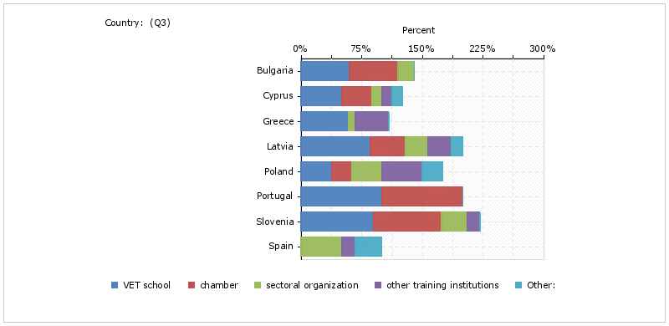

Other remarks regarding apprenticeship coming from SMEs which are involved:
- “movement with mutual benefits” (EL)
- “there should be more practical aspects in VET education” (PL)
- “there are no students interested in apprenticeships” (PL)
- “we would like to participate more” (SL)
- “2 or 3 months are not enough to truly understand the business” (ES)
- “most important thing you can learn during an apprenticeship (in this area) is how to treat people” (ES)
- “the requirements for taking an official apprentice in Spain far outweigh the benefits” (ES)
- “we would be open to the possibility of taking apprentices if the opportunity provided itself in a reasonable way” (ES)

3.2 Intermediary organizations (IMOs)
Among surveyed intermediary organizations, there were 36% of chambers, 24% of sectoral organizations, 21% of centres for vocational education and training and 20% of other intermediary organizations, among them consultancy organizations, continuing professional development organization of VET and in-company tutors, non-profit foundation, R&D centre, universities of applied sciences, business support centre, HR development company, training company, regional federation of industries, labour office, higher education foundation.
Figure 12. Percentage of organisations by type.
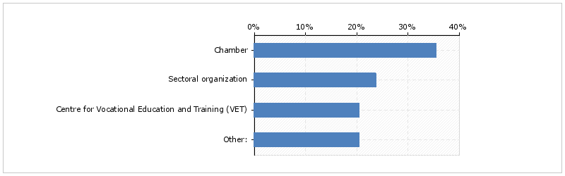
Most of them operate on regional (40%) and national level (34%), while 26% of the surveyed intermediary organizations operate on local level.
Figure 13. Percentage of organisations by level of operation.
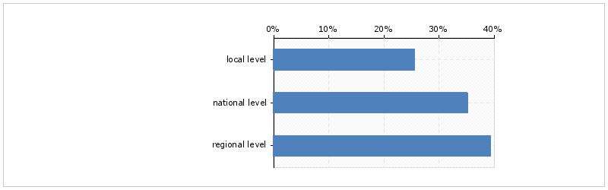

Source of financing of IMOs
43% of all the IMOs surveyed have mix of public and private sources, 42% private sources and 15% public sources.
From Bulgaria, 53% have mix of public and private, 27% public and 20% private.
From Cyprus, 90% of IMOs have private sources and 10% mix of public and private.
From Greece, 63% have mix and 33 % have public funding.
From Latvia, 44% have private, 33% public and 22% mix of both.
From Poland, 61% of IMOs have mix, 22% public sources and 17% private sources.
From Slovenia, 92% have private sources and 8% have mix.
In Spain, 50% have mix of public and private sources, 25% have public and 25% private.
Belgium (N=1): 100% private
Denmark (N=1): 100% public
Finland (N=3): 67% mix and 33% public
Portugal (N=1): 100% mix

Figure 14. Percentage of organisations by source of financing.
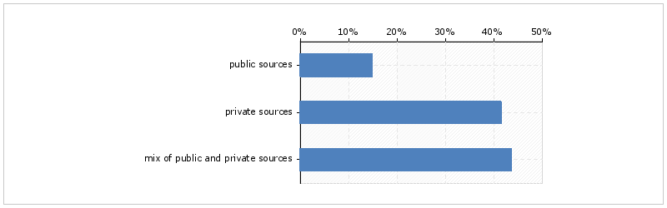

Figure 15. Percentage of organisations by source of financing by country.
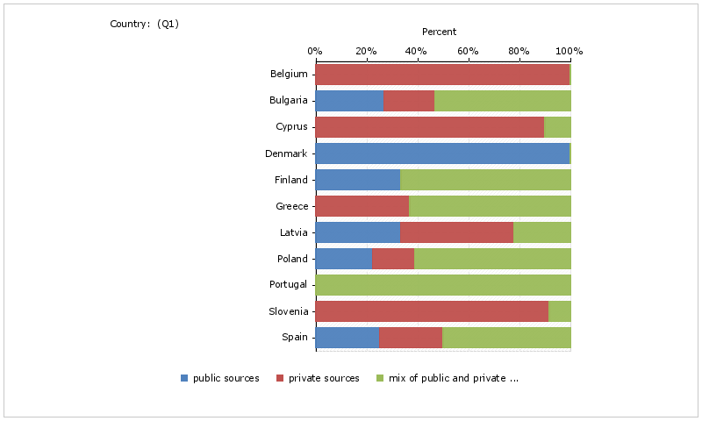

Cooperation
60% of IMOs currently cooperate with companies and 38% would like to strengthen the cooperation.
40% of IMOs currently cooperate with sectoral organizations and 53% would like to strengthen the cooperation.
46% of IMOs currently cooperate with VET schools and 48% would like to strengthen the cooperation.
39% of IMOs currently cooperate with national or regional state organizations and 58% would like to strengthen the cooperation.
43% of IMOs currently cooperate with other chambers and 53% would like to strengthen the cooperation.
Figure 16. Organisations’ current cooperative efforts and preferences for future cooperation.
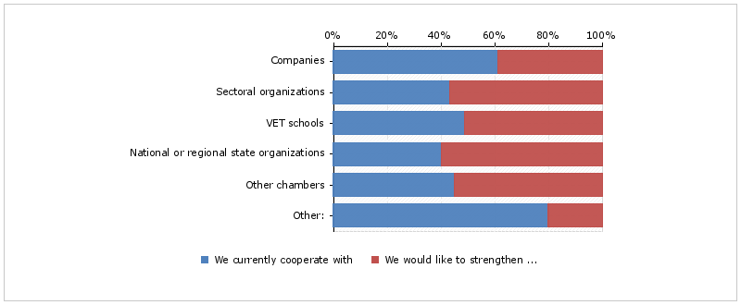
Other organizations mentioned among those IMOs currently cooperate or would like to strengthen the cooperation with are European institutions and municipalities (5%).

Improvement of service offer
78% of IMOs would like to improve their service offer regarding promotion of apprenticeship among SMEs.
71% of IMOs would like to improve their service offer in regards to creating links between VET organizations and SMEs.
71% of IMOs would like to improve their service offer in regards to building of networks among SMEs and other stakeholders to support apprenticeships.
65% of IMOs would like to improve their service offer in regards to raising interest among students in vocational training to work in SMEs.
62% of IMOs would like to improve their service offer regarding promotion of vocational professions, especially those in need of workers
54% of IMOs would like to improve their service offer in regards to supporting SMEs to select appropriate candidates for apprenticeship (match-making).
52% of IMOs would like to improve their service offer in regards to support for in-company trainers/mentors to gain knowledge about training methods etc.
47% of IMOs would like to improve their service offer in regards to support for in-company trainers/mentors to gain practical knowledge.
41% of IMOs would like to improve their service offer in regards to support for in-company trainers/mentors to obtain mentor certifications.
41% of IMOs would like to improve their service offer in regards to support for in-company trainers/mentors with monitoring and supervision of apprenticeships.
40% of IMOs would like to improve their service offer in regards to support for in-company trainers/mentors to manage the apprenticeships internally.
39% of IMOs would like to improve their service offer in regards to support for in-company trainers/mentors to deal with the administrative work.
Figure 17. Organisations' expressed preference for improvement of service offer.
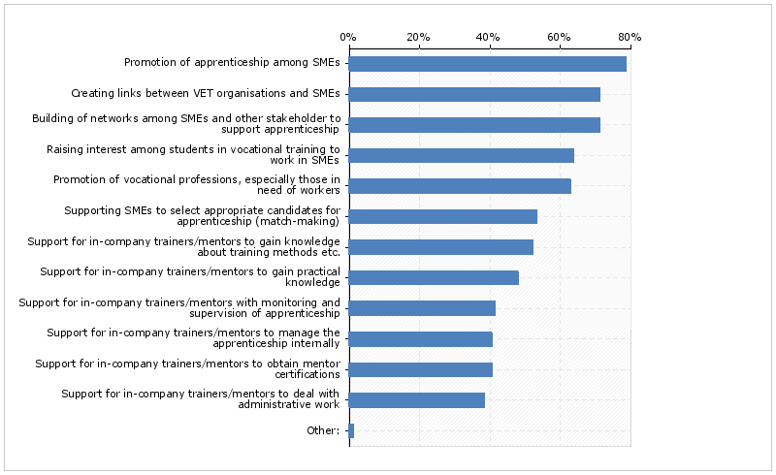

Improvement of competences
66% of IMOs would like to improve their competences regarding promotion of apprenticeship among SMEs.
57% of IMOs would like to improve their competences in regards to building of networks among SMEs and other stakeholders to support apprenticeships.
54% of IMOs would like to improve their competences in regards to raising interest among students in vocational training to work in SMEs.
49% of IMOs would like to improve their competences regarding promotion of vocational professions, especially those in need of workers
49% of IMOs would like to improve their competences in regards to support for in-company trainers/mentors to gain knowledge about training methods etc.
47% of IMOs would like to improve their competences in regards to creating links between VET organizations and SMEs.
47% of IMOs would like to improve their competences in regards to support for in-company trainers/mentors to gain practical knowledge.
45% of IMOs would like to improve their competences in regards to support for in-company trainers/mentors with monitoring and supervision of apprenticeships.
41% of IMOs would like to improve their competences in regards to supporting SMEs to select appropriate candidates for apprenticeship (match-making).
41% of IMOs would like to improve their competences in regards to support for in-company trainers/mentors to obtain mentor certifications.
38% of IMOs would like to improve their competences in regards to support for in-company trainers/mentors to manage the apprenticeships internally.
37% of IMOs would like to improve their competences in regards to support for in-company trainers/mentors to deal with the administrative work.
Figure 18. Organisations' expressed preference for improvement of competences.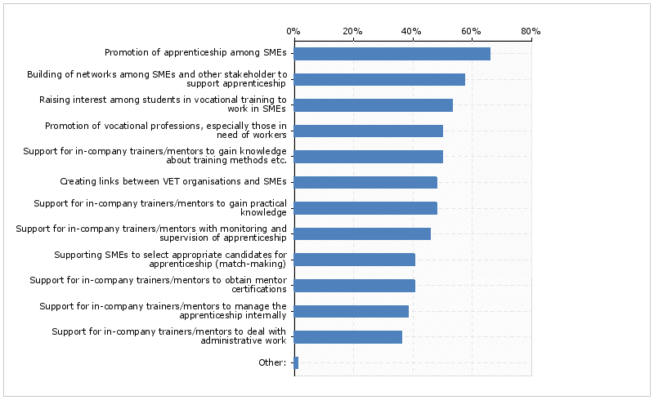

Preferred options for training
69% of IMOs would prefer learning materials, 68% combination of e-learning and face-to-face trainings; 63% would prefer online tools; 40% would prefer online trainings; 26% would prefer face-to-face trainings.
Figure 19. Organisations’ preferred options for training.
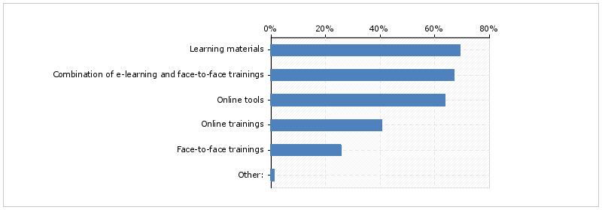

4. Conclusions
Both SMEs which are and are not involved in WBL would like to see the strengthening of vocational education as career option, stating that more information for students about vocational education as career option should be provided and the image and prestige of vocational education should be raised.
Although work-based learning and apprenticeship in particular has been on the (political) agenda for the past years, there is still lack of information among companies, especially SMEs, but also among VET students, as difficulties to find vocational students are one of the main hindrances recognized by the SMEs that participated in the survey for involving in WBL. Another main issues is skills mismatch.
Assuring appropriate quality of trainings in companies is a major concern for VET schools, but also for SMEs, according to the results. SMEs need support to get involved in WBL/apprenticeship and need to acquire appropriate trainings and competences. Intermediary organizations should respond to these needs, but need appropriate training as well. Further steps in developing appropriate training programmes under the EAPPREN project will follow on the basis of this survey findings.

5. Annexes

5.1 Infographics TBA

5.2 Data tables TBA

https://ec.europa.eu/digital-single-market/en/news/communication-rethinking-education

